When changes are made to the EmpowerNETMain or EmpowerNETDocumentation repositories we need to Sync the repository them Commit and Push the changes to Github.
In Visual Studio:
connect to the local repository using the Git tab on the menu bar,
Local Repositories from the pop-up menu
Or
Connect to the local repository using the Team Explorer tab at the bottom of the VS Navigation panel.

Click on the Git Changes tab at the bottom.
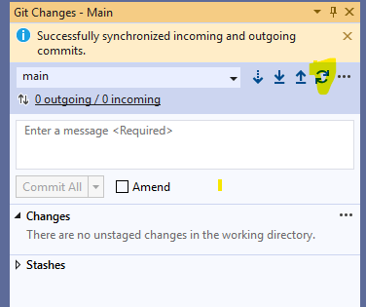

Click on the Sync icon (highlighted above). This makes sure you receive changes made on the other laptop before committing your new changes.

Next, enter a message describing your changes and then click on Commit and Push from the drop down.

This sends the changes to Github.

Next, it is best to login to the other laptop and Sync the local repository to Github as this ensures the two laptops have the same source.

